Webcam Support

***Your new laptop is equipped with a webcam, which has been disabled by default***

1. To enable your Webcam please visit [www.request.ford.com](http://www.request.ford.com)
2. Enter “ Software Install ” in the Search Field (Located at the top of the page)



1. Click the “Application Self Service” link under the Self-Service Software Install/Remove Section

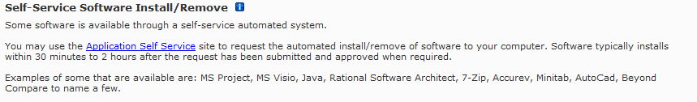

1. Enter “Dell” in the Search Field located on the Self-Serve Software page

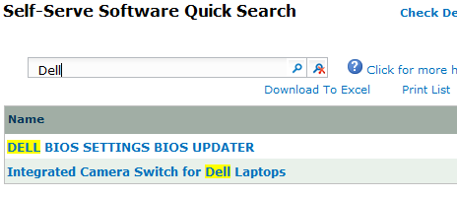

1. Click on “Integrated Camera Switch for Dell Laptops” to request the software to enable your Webcam.

***Your new webcam can be used with the Standard Global Client Software***